Vehicle Type Configuration 2016 UP375 Specific – CGEA1.3

Functional Description

Off Road (Truck Apps) Level 1 & Level 2 Screens – CGEA 1.3 v3.0 uses Off_Road_Screen_Vehicle_Type_Cfg value to determine whether to use a Pick Up Truck or SUV type graphic. The intent for 2016 UP375 is to extend use of this configuration value to control the graphic (Pick Up Truck or SUV) for other STSS screens or warnings.

Interfaces

Inputs
- Off_Road_Screen_Vehicle_Type_Cfg as defined in Off Road (Truck Apps) Level 1 & Level 2 Screens – CGEA 1.3 v3.0 STSS

Outputs

Graphic Pick Up Truck or SUV as defined by HMI

Function/Performance

Operational Modes

See associated STSS or specification.

Voltage Levels

See associated STSS or specification.

Human-Machine Interface

Visual

Indicator Graphics / Display Format

Pick Up Truck or SUV vehicle graphic as per HMI

Indicator Color Coordinates

N/A

Indicator Characteristics

Pick Up Truck or SUV vehicle graphic as per HMI

Audio

None

Switch Control Logic

Not Applicable

System Accuracy

The Pick Up Truck or SUV graphic shall change to the appropriate graphic within 100 msec of a configuration change.

Operation: Performance and Functional

Subsystem Algorithm Flowchart / State Diagram
Table 1.0 State Matrix for Off_Road_Screen_Vehicle_Type_Cfg
STSS / Feature/ W# or applicable display. | Off_Road_Screen_Vehicle_Type_Cfg  (defined in Off Road (Truck Apps) Level 1 & Level 2 Screens – CGEA 1.3 v3.0)
STSS / Feature/ W# or applicable display. | Pick Up Truck (0x0) | SUV (0x1)
Door, Liftgate, Liftgate/Liftglass Ajar RTT; Trunk Ajar RTT; Hood Ajar RTT; and Messages CGEA1.3  Hood Ajar (W106)  Hood Ajar RTT is the only function in this STSS with unique vehicle outline. |  | 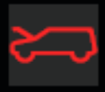
AWD Gauge – CGEA 1.3  AWD Gauge/Power Distribution  (On Demand Info Screen Only) |  | 
Off Road (Truck Apps) Level 1 & Level 2 Screens – CGEA 1.3 v3.0  OFF Road Screen  (On Demand Info Screen Only)  Note: Off Road Screen Function is also defined in Off Road (Truck Apps) Level 1 & Level 2 Screens – CGEA 1.3 v3.0 | 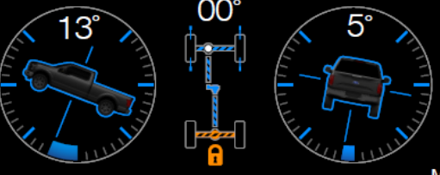 | 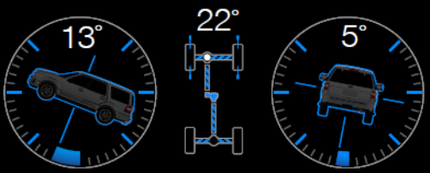
See CADS Specification  ACC  (Status Graphic) | 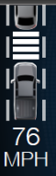 | 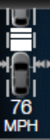
Warning – Park Aid – CGEA1.3  Rear/  Front Park Aid  (W346, W347, W353) | 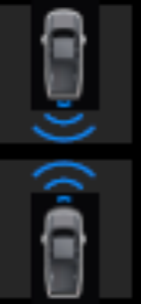 | 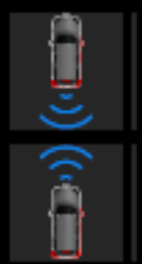
Blind Spot Monitor with Cross Traffic Alert – CGEA1.3  Cross Traffic Alert  (W441, W442, W444) | 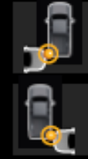 | 
Notes:

Operation Description (supports algorithm flowchart /state diagram)

- Applies to all Info Screens, Settings Screens, and Warning Messages (where per the Global
Text Message list an Icons is associated with the warning).
- Hood ajar is the only closure warning which has unique Truck / SUV graphics.
- Graphics are for explanatory purposes only HMI to provide production graphics.
- Vehicle_Type is defined in Table 1.13 of Off Road (Truck Apps) Level 1 & Level 2 Screens – CGEA 1.3 v3.0 could be used instead of Off_Road_Screen_Vehicle_Type_Cfg. It was decided to use the Off_Road_Screen_Vehicle_Type_Cfg as Vehicle_Type variable is really not needed.

Function Safety Classification (EMC)

Class B

Memory Storage

Parameter Name | Description | Value at  Battery Connect | Value at  Module Wake-up
Off_Road_Screen_Vehicle_Type_Cfg | Parameter which defines which graphic to display Pick Up Truck or SUV | Defined in Off Road (Truck Apps) Level 1 & Level 2 Screens – CGEA 1.3 v3.0 STSS
Operational_Mode | 4 state indicator for cluster operational mode | Limited | Limited, Normal or Crank

Prove Out

No

Reconfigurable Telltale

No

Message Center Msg

See associated STSS or specification.

Error Handling

Missing Message Strategy

See associated STSS or specification.

Diagnostics

Self Test

None

Engineering Test Mode

N/A

Part II Performance

Supported Diagnostic Trouble Codes (DTCs)
DTC | Description
 | See associated STSS or specification.

Block  Num | Block Description | Size (bits) | Type | Byte(s) | Bits | State: Description | "0" | "1" | Default | Comments/  Information
PACKETED BLOCKS
$xx | Option Content (B&A) |  | 1 | * | * | Off Road Screen Vehicle Type | Pick Up Truck | SUV | Pick Up Truck
*Byte and bit location to be identified in Part II Specification for this cluster

Revision History
SPSS Module Revision History

Revision Level | Name | Change Description | Date
1.0 | J.Blatchford | Initial Release | 6/19/2014

